1. Text

   Description automatically generated
2. **Agenda**:
   1. Scope of a variable.
   2. When to use?
3. 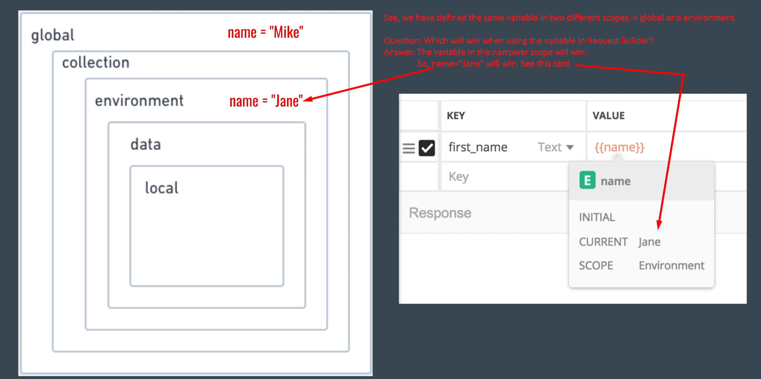
4. 
5. **Global**:  
   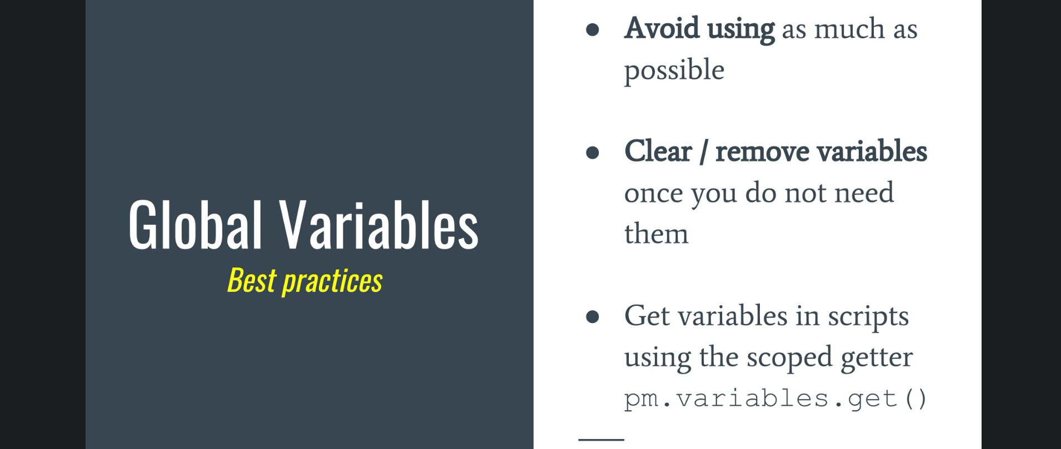
   1. **When to use**?
   2. **Best practices**:  
      -> If you put API Key or token in global scope, and at the same time you have more than one collection for different APIs, it would be confusing for you to know for which API, this API key is or the token is.
   3. **How to access global variable’s value**:
      1. Using pm.globals.get(<key>)
      2. **Using Scope Global Variable**: It means variable’s value will be resolved as per scope.
         1. **In Request Builder** 🡺 {{<key>}}
         2. Using **pm.variables.get**(<key>)
            1. The advantage of pm.variables.get(<key>) is that if later on you change the scope of the variable, this statement will work but pm.globals.get(<key>) will not.
            2. Graphical user interface, application

               Description automatically generated
6. **Environment Variables**:  
   Graphical user interface, application

   Description automatically generated
   1. **When to use**?
      1. When the same collection has to be run against different servers 🡺 Dev, Test, UAT etc.  
         You want to generalize URL, Authentication Credentials etc. for each environment.
      2. When you have one collection, even then you can use it to share info among other requests.   
         Unlike global scope, if you run a request in the env where variable is defined, the variable value will be available whereas if it is defined in global scope, value will always be present.   
         Graphical user interface, application

         Description automatically generated
      3. 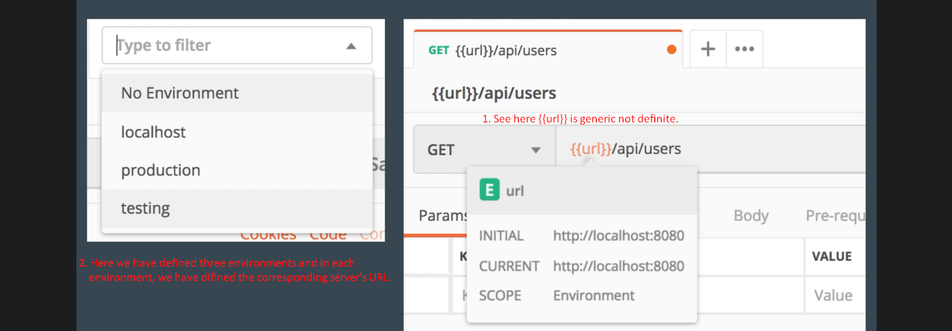
   2. **Best Practices**:
      1. 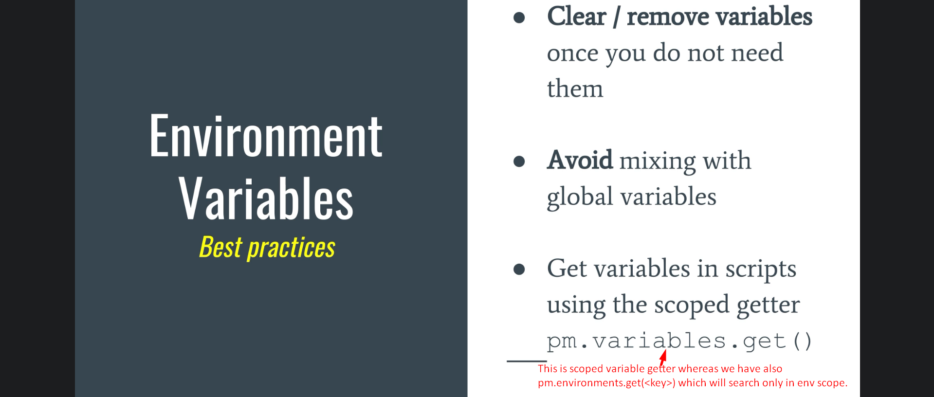
7. **Collection Variables**:  
   
   1. **When to Use**?  
      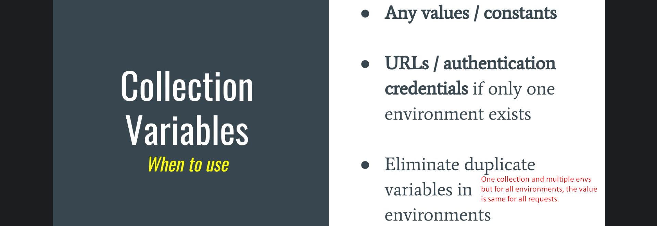
      1. When a variable must be used within a collection boundary and not related to a specific environment.
   2. **How to get value**?
      1. 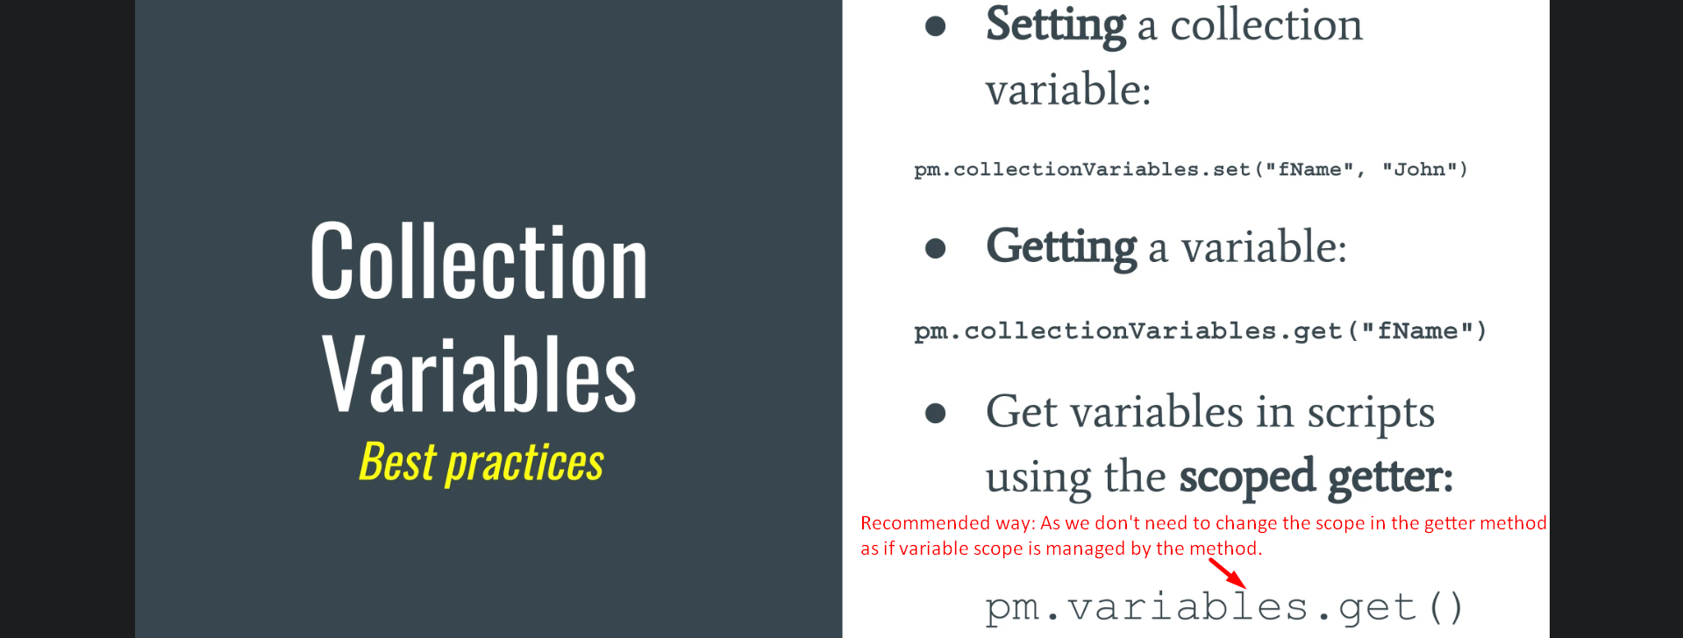
8. **Data Variables**:  
   Graphical user interface, application

   Description automatically generated
   1. **When to Use**?
      1. When we have multiple data set. Means when we want to run the same request for multiple data set.  
         **NOTE**: In this case, this is not an alternative.
   2. Data Variables exist only during the iteration (one iteration for each record in the Data Set).  
      **NOTE**: Iteration can be created only through the **Collection Runner or Newman**.  
      **NOTE**: Supported files 🡺 JSON, CSV files.
9. Graphical user interface

   Description automatically generated